**CLIMATE CHANGE AND NANOSCIENCE**

**PROF. RAJENDRA SINGH (RAJJU BHAIYA UNIVERSITY), PRAYAGRAJ**

**HEMWATI NANDAN BAHUGUNA GOVT. PG COLLEGE NAINI PRAYAGRAJ**

**DISSERATION SUBMITTED FOR AWARD OF**

**MASTER OF SCIENCE**

**IN PHYSICE**

**2024-2025**

**UNDER THE SUPERVISION OF**

**DR. AASHIT JAISWAL**

**SUBMITTED BY**

**SAMIKSHA PANDEY**

**M.SC (IV Semester)**

**Roll No:- 2412495921008**



**DEPARTMENT OF PHYSICS**

**IN PARTIAL FULFILLAMENT OF THE REQUIREMENT FOR THE DEGREE OF MASTER OF SCIENCE IN PHYSICS**

**CERTIFICATE**

This is certifying that **SAMIKSHA PANDEY** which have “**CLIMATE CHANGE AND NANOSCIENCE**” to under the supervision of **Dr. AASHIT JAISWAL** Department of Physics **Hemwati Nandan Bahuguna Govt PG College Naini Prayagraj** has completed the Dissertation.

I gladly grant permission to submit this dissertation and wish the researcher a bright future.

SUPERVISION

DR. AASHIT JAISWAL

HEMWATI NANDAN BAHUGUNA GOVT PG COLLEGE NAINI PRAYAGRAJ

**Date:**

**DECLARATION**

**SAMIKSHA PANDEY** hereby that this submission is my own work and that the best of my knowledge and belief, it contains no material previously published or written by another person nor material which to a substantial extent has been accepted for the award of any other degree of the university or other institute of higher learning except where the acknowledgement has been made in text.

**Table of contents**

**SAMIKSHA PANDEY**

**MSC(IV SEMSTER)**

**ROLL NO. 2412495921008**

**M.SC (IV Semester)**

**Roll No:- 2412495921010**

|  |  |
| --- | --- |
| Sr no. | Contents |
| 1 | Introduction |
| 2 | Nanoscience classification and synthesis |
| 3 | Climate change: A serious problem |
| 4 | Mitigating climate change with Nano-technology |
| 5 | Conclusion and Recommendation |

# Abstract:

Climate change is a major global problem caused by greenhouse gases like carbon dioxide and methane. These gases come from human activities such as burning fossil fuels and cutting down forests. They trap heat in the atmosphere, leading to rising temperatures, floods, droughts, and other harmful effects. To fight this, we need smart, clean, and efficient technologies. One powerful solution is nanotechnology. We need smart solutions to reduce these effects. One such solution is nanotechnology—the science of using very tiny materials.

Nanotechnology helps by making solar panels more efficient and batteries last longer, supporting clean energy. It also improves carbon capture, which removes harmful gases from the air. Nanomaterials can clean polluted water and air, and help make eco-friendly products like stronger building materials.

In conclusion, nanotechnology is a useful tool to reduce emissions, support green energy, and protect the environment. With careful use and research, it can play a big role in slowing down climate change and creating a healthier planet.

Chapter-1

1. Introduction

# (1.1). Definition of Climate Change

Climate change refers to long-term shifts in temperature, precipitation, wind patterns, and other elements of the Earth's climate system. These changes can be natural, resulting from variations in solar energy, volcanic activity, and Earth's orbit, or human-induced due to greenhouse gas emissions from fossil fuel burning, deforestation, and industrial activities.

## History of climate change

The idea that human actions could impact Earth’s climate by raising carbon dioxide levels was first proposed by Swedish scientist Svante Arrhenius in 1896. He estimated how increased CO2 could lead to global warming. Decades later, in 1938, Guy Callendar provided evidence connecting the growing CO2 levels in the atmosphere to rising global temperatures.

Climate change refers to long-term shifts in temperatures and weather patterns. Such shifts can be natural, due to changes in the sun’s activity or large volcanic eruptions and Earth's orbit. [human activities have been the main driver of climate change](https://www.ipcc.ch/2021/08/09/ar6-wg1-20210809-pr/), primarily due to the burning of fossil fuels like coal, oil and gas.

Burning fossil fuels generates greenhouse gas emissions that act like a blanket wrapped around the Earth, trapping the sun’s heat and raising temperatures.

The main greenhouse gases that are causing climate change include carbon dioxide and methane. These come from from fossil fuel burning, deforestation, and industrial activities,using gasoline for driving a car or coal for heating a building, for exampleClearing land and cutting down forests can also release carbon dioxide. Agriculture, oil and gas operations are major sources of methane emissions. Energy, industry, transport, buildings, agriculture and land use are among the [main sectors](https://www.unep.org/interactive/six-sector-solution-climate-change/) causing green house gases

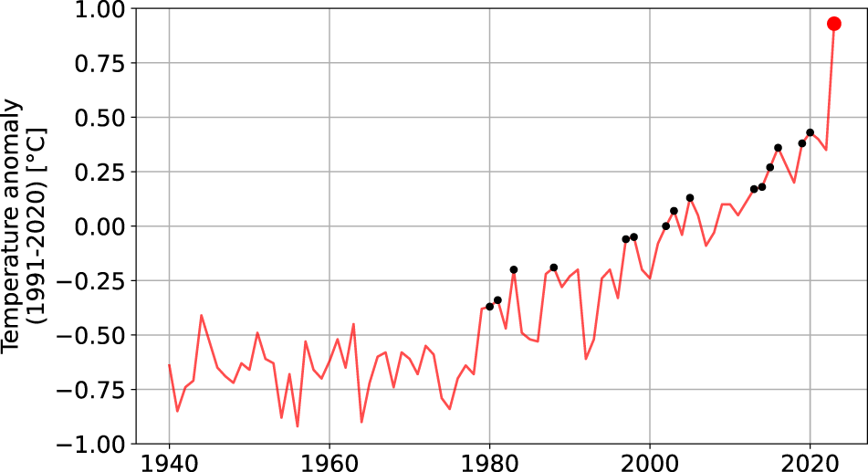

(Rising in global temperature)

## (1.2). Green House Gases

#### First of all, there are several key greenhouse gases to consider — carbon dioxide (CO2), methane (CH4), nitrous oxide (N2O), and so-called f-gases (mainly hydrofluorocarbons, chlorofluorocarbons, and other fluorinated gases). It’s not just CO2

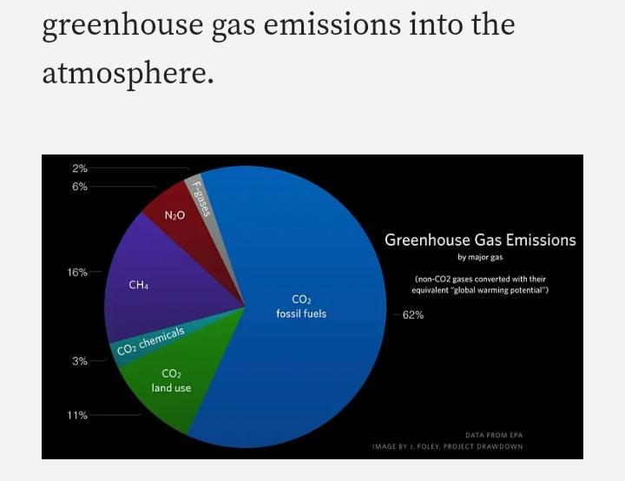

• greenhouse gases that are warming the world faster than at any time in at least the last two thousand years.

• [The average temperature of the Earth’s surface is now about 1.2°C warmer](https://wmo.int/news/media-centre/climate-change-indicators-reached-record-levels-2023-wmo) than it was in the late 1800s (before the industrial revolution) and warmer than at any time in the last 100,000 years. The [last decade (2011-2020) was the warmest on record](https://wmo.int/media/news/2020-was-one-of-three-warmest-years-record), and each of the last four decades has been warmer than any previous decade

# (1.3). Introduction to nanoscience

1. Nanoscience is the study and manipulation of matter at the nanoscale (1-100 nanometers), a scale where unique phenomena and properties emerge, enabling novel applications in diverse fields like materials science, medicine, and electronics.

The prefix "nano" originates from the Greek word meaning "dwarf" or something very small. It represents one billionth of a meter (10⁻⁹ m).

1. It's important to distinguish between **nanoscience** and **nanotechnology**:

**Nanoscience** is the study of structures and molecules at the **nanometer scale**, typically ranging from **1 to 100 nanometers** (nm).

**Nanotechnology** is the **application** of nanoscience — using this knowledge to develop **practical devices and solutions**.

1. Nanoscience is considered one of the most **promising technologies of the 21st century**. It involves converting nanoscience theory into practical applications through observing, measuring, manipulating, assembling, controlling, and manufacturing matter at the nanometer scale.

# (1.4). Climate Change and Nanoscience

⬤ Nanoparticles are being developed to reduce greenhouse gas emissions

⬤ The addition of nanoparticles to fuel can improve fuel efficiency and reduce the rate of greenhouse gas production

* Encourage better air-to-fuel mixing and and enhance chemical reactivity during combustion, leading to better performance, combustion, and quality of emissions

⬤ Carbon sequestration

* Nanomaterials can convert carbon dioxide(CO2) into useful products like alcohol
* The materials could be simple chemical catalysts or photochemical in nature that work be presence of sunlight

## (i). Water Treatment and Purification

● Nanotechnology can be used to help provide more clean water to people across the world

● Industrial pollutants, oil spills, naturally occurring pollutants, etc.

●New generation of nanomembranes for separation to enable greater water purification and desalination

* Better means of removing, reducing, or neutralizing water contaminants

## (ii). Air Purification

● Nanotechnology can be used to remove toxins from the air

● CO2 from waste gases

* Traditional methods are expensive, utilize chemicals, and are uncompetitive

● Ultra-thin nanoscale polymer film that filters out CO2

● Volatile organic compounds (VOCs) also represent a hazard to air quality, contributing to smog and high ozone levels

* Porous manganese oxide with gold nanoparticles grown into it as a catalyst to decomp and remove the offending compound

## (iii). Prevention and Preparedness

* Nanotechnology can help stop pollution before it even starts.
* Pollutants that occur naturally, such as heavy metals and organic compounds.
* Recycling of batteries and other electronic devices.
* Nanomaterials can often be reused or recycled multiple times.
* This leads to lower consumption of raw materials.

## (1.5). How Nanoscience Supports the Fight Against Climate Change

#### 1. Green Energy Generation:

Solar Power: Special nanomaterials like quantum dots and perovskites are helping build solar panels that are not only more efficient but also lighter and more flexible.

Hydrogen Fuel: Tiny catalysts at the nanoscale boost the process of splitting water to create clean hydrogen energy.

#### 2. Better Energy Storage:

Batteries and supercapacitors made with nanostructured materials charge quickly, last longer and store energy more efficiently.

### 3. Capturing Carbon:

Materials with nano-sized pores, such as MOFs (metal-organic frameworks), are great at trapping carbon dioxide directly from the air or industrial gases.

### 4. Reducing Pollution:

Vehicle Emissions: Nano-catalysts help clean up exhaust gases, cutting down toxic emissions.

Water Cleaning: Nanoscale filters and particles are effective in removing pollutants from water, making it cleaner and safer.

### 5. Smarter Farming:

Nano-based fertilizers and pesticides work more precisely, reducing waste and environmental harm while boosting crop productivity.

Chapter 2:

# (2.1). Nanoscience and Nanotechnology

## (a). Definition of Nanoscience

Nanoscience is the study and manipulation of matter at the nanoscale (1-100 nanometers), a scale where unique phenomena and properties emerge, enabling novel applications in diverse fields like materials science, medicine, and electronics

## (b). History of Nanoscience

Norio Taniguchi, Japanese scientist, mentioned the term ‘nanotechnology’ for the first time in 1974 in his paper on synthesis technology to create objects and features of nanometer dimension

"American scientist Richard Feynman was the first to talk about nanotechnology as an important and new area of science. In 1959, he gave a famous talk called 'There’s Plenty of Room at the Bottom,' which has been used many times in discussions about this field."

## Nanomaterials

• Nanomaterials are defined as those materials which have structured components with size less than 100nm atleast in one dimension.

• Materials that are nanoscale in one dimension are layers such as thin films or surface coatings.

• Materials that are nanoscale in two dimensions are nano wires and nano tubes.

• Materials that are nanoscale in three dimensions are precipitates colloids and quantum dots.

• Nanostructured materials are materials where the dimensions are in the range of 1 to 100nm (i.e. from the size of the atom to the wavelength of the light.)

## Nano Science

Nanoscience can be defined as the study of phenomena and manipulation of materials at atomic, molecular and macromolecular scales, where properties differ significantly from those at a large scale.

## Nanotechnology

Nanotechnology can be defined as the design, characterization, production and application of structures, devices and systems by controlling shape and size at the nanometre scale.

## (2.2). Importance of Nanoscience

1. Revolutionizing Technology – Nanoscience enables the development of smaller, faster, and more efficient electronic devices.

2. Medical Advancements – It plays a crucial role in drug delivery systems, cancer treatment, and diagnostic tools.

3. Environmental Benefits – Nanotechnology helps in water purification, pollution control, and renewable energy solutions.

4. Stronger and Lighter Materials – Nanomaterials enhance the strength, flexibility, and durability of products like aircraft, sports equipment, and construction materials.

5. Sustainable Energy – It contributes to the development of high-efficiency solar cells, energy storage devices, and hydrogen fuel cells.

## (2.3). CLASSIFICATION OF NANOSTRUCTURES

Nanomaterials can be categorized based on dimensions, origin and their structural configuration as follow

## a. Classification based on dimensions:

Classification is based on the number of dimensions, which are not confined to the nanoscale range (<100 nm).

(1) zero-dimensional (0-D),

(2) one-dimensional (1-D),

(3) two-dimensional (2-D), and

(4) three-dimensional (3-D).

## 1. Zero dimensional:

These are the materials having allthe dimensions within the nanoscale (no dimensions are larger than 100 nm). Small clusters composed of a few to roughly a hundred metal atoms, and common spherical metal nanoparticles.

Example: Quantum dots, Nanodots, Nanoclusters and Fullerenes.

## 2. One dimensional:

These are the materials having one dimension outside the nanoscale (one dimension is larger than 100 nm). Major growth occurs in one dimension, whereas it is limited in the other two dimensions

Example: Nanowires, Nanorods, Nanotubes, Nanowires, Nanobelts, Nanopillars, Carbon Nanotubes

## 3. Two dimensional:

These are the materials having two dimensions outside the nanoscale. (Two dimensions are larger than 100nm). This class exhibits plate-like shapes.

Example: Graphene, nanofilms, nanoplates, nanonetwork, planar triangle, hexagons and discs.

## 4. Three dimensional:

These are the materials that are not confined to the nanoscale in any dimensions. (All three dimensions are larger than 100nm). Major growth occurs in all three dimensions, more complicated structures like various polyhedral, as well as assemblies of OD, 1D and 2D nanostructureExample: -Graphite, Diamond, Nanosponge Nanocomposite, dispersion of nanoparticles, a bundle of nanowires.

* 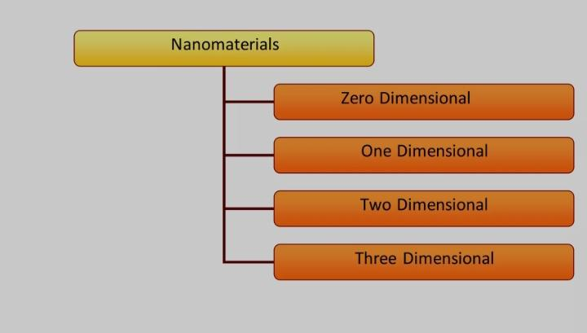

## 

## b. Classification based on structural configuration:

1. Carbon Based Materials

2. Metal Based Materials

3. Dendrimers

4. Composites

## (i). CARBON BASED NANOMATERIALS

• These nanomaterials are composed mostly of carbon, most commonly taking in the form of hollow spheres, ellipsoids, oг tubes.

• Spherical and ellipsoidal carbon nanomaterials are referred to as fullerenes, while cylindrical ones are called nanotubes.

• These particles have many potential applications, including improved films and coatings, stronger and lighter materials, and applications in electronics.

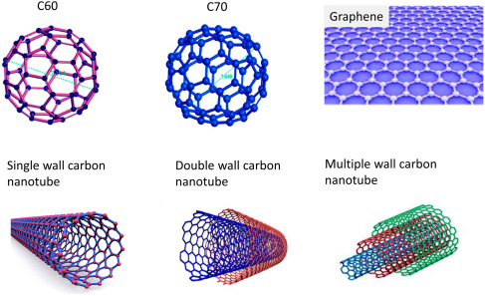

## (ii). METAL BASED NANOMATERIALS

• These nanomaterials include quantum dots, nanogold, nanosil metal oxides, such as titanium dioxide.

• A quantum dot is a closely packed semiconductor crystal composu us hundreds or thousands of atoms, and whose size is on the order of a fou nanometers to a few hundred nanometers. Changing the size of c dots changes their optical properties.

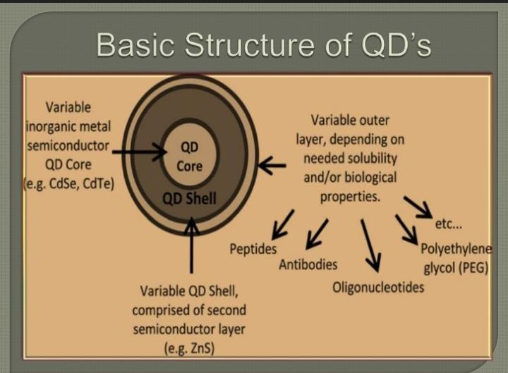

## (ii). DENDRIMERS

• These nanomaterials are nanosized polymers built from branched units. The surface of a dendrimer has numerous chain ends, which can be tailored to perform specific chemical functions. This property could also be useful for catalysis.

• Three-dimensional dendrimers contain interior cavities into which other molecules could be placed, they may be useful for drug delivery.

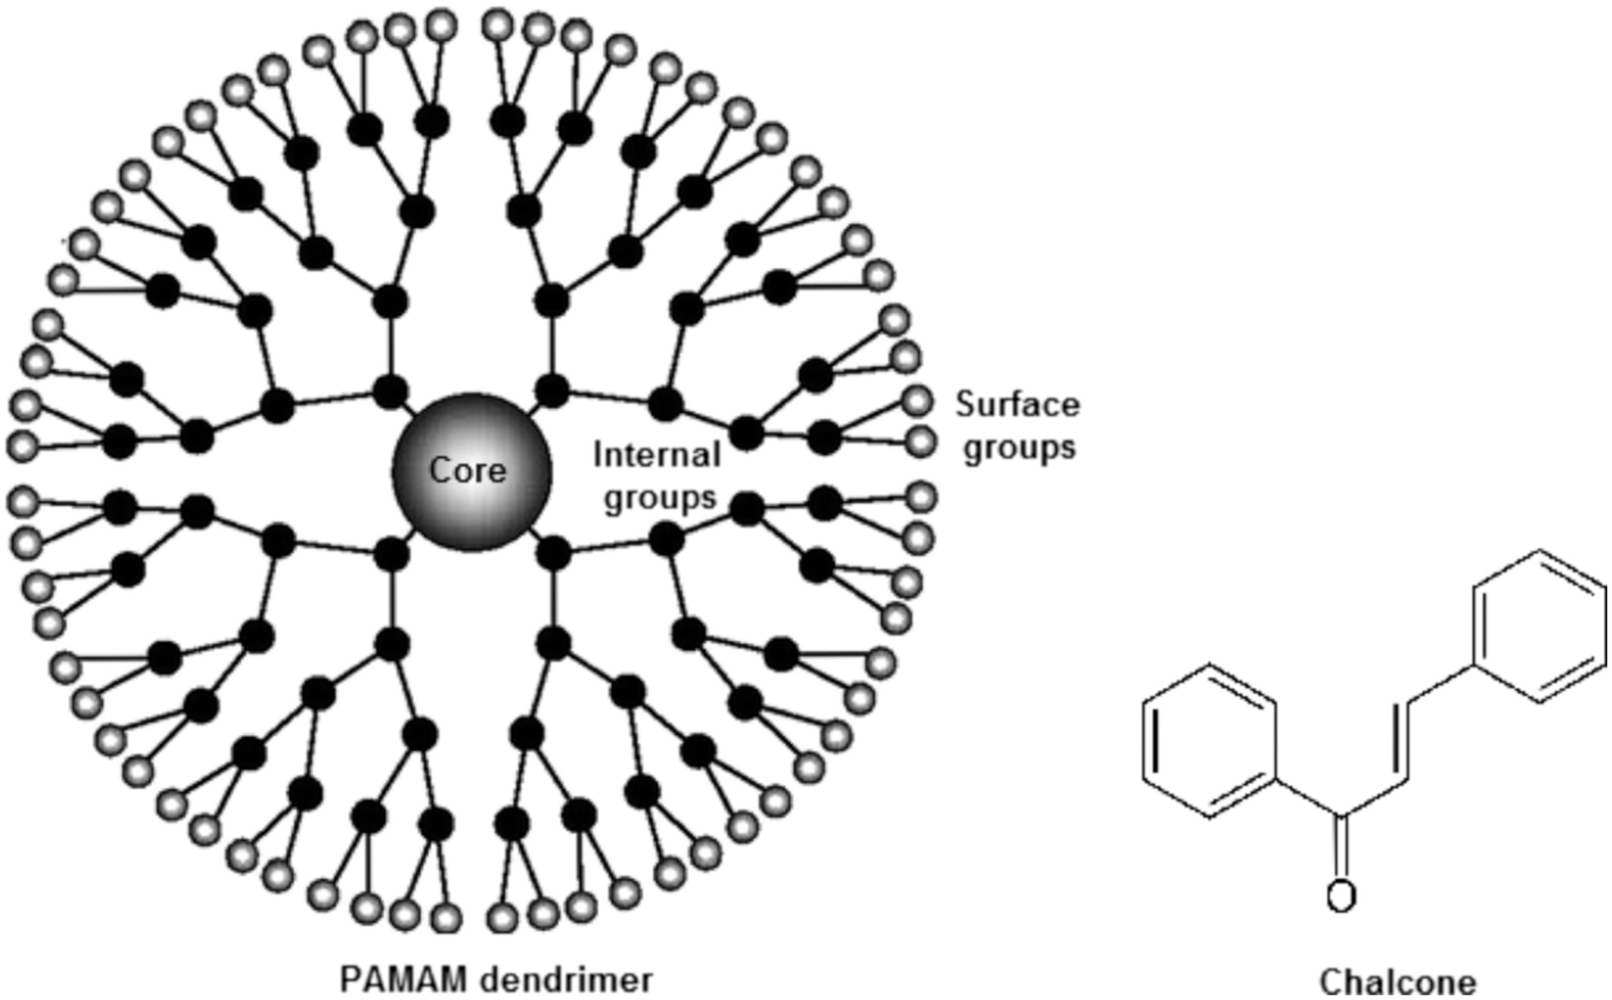

## (iii). COMPOSITES

Composites combine nanoparticles with other nanoparticles or with larger, bulk-type materials. Nanoparticles, such as nanosized clays, are already being added to products ranging from auto parts to packaging materials, to enhance mechanical, thermal, barrier, and flame-retardant properties

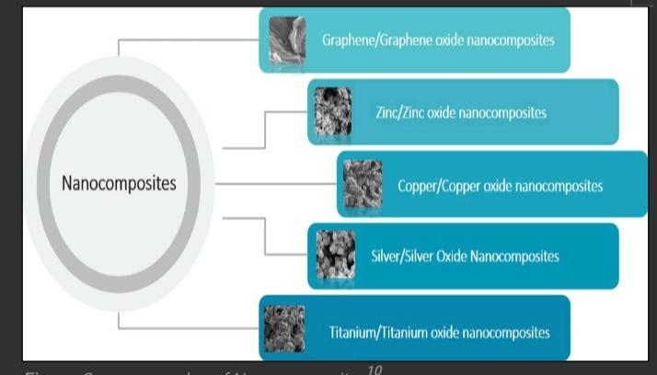

# (2.4). Properties of nanomaterials

1. High Surface Area to Volume Ratio

• Nanomaterials have a much larger surface area compared to their volume

• This increases chemical reactivity and adsorption capacity.

• Useful in catalysis, drug delivery, and sensor technology.

## 2. Optical Property

Nanomaterials interact with light in unique ways.

Quantum size effects cause materials to emit or absorb light differently.

Example: Gold nanoparticles appear red or purple depending on size.

## 3. Electrical Properties

Nanomaterials can be conductors, semiconductors, or insulators based on size and shape.

Quantum tunneling and electron confinement affect conductivity.

Used in nanoelectronics and transistors.

## 4. Mechanical Properties

Stronger and more durable than bulk materials.

For example, carbon nanotubes are stronger than steel but lighter.

High elastic modulus and hardness

## 5. Magnetic Properties

Nanoparticles can show superparamagnetism — magnetic only in the presence of a magnetic field.

Useful in MRI contrast agents and data storage.

## 6. Chemical Reactivity

Nanomaterials often show higher reactivity due to more atoms on the surface.

Important for chemical sensors, fuel cells, and environmental applications.

Here's a refined and structured version of your content on **applications of nanotechnology**, suitable for academic or presentation purposes:.

## 7.Quantum Effects

At the nanoscale, quantum mechanics starts to dominate over classical physics.

This leads to unique optical, electrical, and magnetic properties.

## 8.Biological Properties

Easily interact with cells and biomolecules.

Useful in drug delivery and diagnostics.

Show strong antimicrobial properties.

Can cross biological barriers (e.g., blood-brain barrier).

Biocompatible and biodegradable (safer use).

May cause immune response or toxicity.

# (2.5). Synthesis of Nanomaterials:

There are two general approaches to the synthesis of nanomaterials and the fabrication of nanostructures. They are :

(1) top-down approach

(2) bottom-up approach

Top-Down Approach and

Bottom-up Approach

• Nanostructure materials have attached a great deal of attention. because their physical, chemical electronic and magnetic properties show a dramatic change from higher dimensional Counterparts and on their shape and size

• Many techniques have been developed to synthesize and fabricate nanostructure materials with controlled shape,size dimensionality and structure.

• The performance of materials depend on their properties. The properties in term depend on atomic structure, Composition, microstructure, defects and intesifaces which are controlled band by thermodynamics and kinetics of synthesis.

## Classification of Techniques for synthesis of Nonomaterials:

There are two general approaches for the synthesis as of nanomaterials.

(1) top-down approach

(2) bottom-up approach

(a). Top-Down Approach

Top-Down Approach involves the breaking down of the bulk materials in to.. nonosized Structures or particles.

Top-down synthesis techniqes are extension of those that have been used for producing micron sized barticles.

Top-down approch are inherently simpler and depend either on removal or division of bulk material or on miniaturisation of bulk fabrication processes to produce the desired structure with appropriate properties.

The biggest problem with the top-down approach is the imperfection of Surface structure

For Exemple: nanowire's made by Lithography are not smooth and may contain a lot of impurities and structural defects on its surface.

• For examples of such techniques are high energy wet ball miling, e-beam Lithography, atomic-force , manipulation, gas-phase, aerosol spray e.t.c.

(b). Bottom-up Approach

The alternative approach, which has the potential of creating less waste and hance the more economical ,is the bottom - up approach

Bottom up Appolooch refers to the build up of materials from the bottom. atom by atom, molecule by molecule by clustuse. , by clusture

Many of these techniques are stil undest development. or are just beginning to be used for commercial production of nanopowders.

Organometallic chemical route, sol-gel synthesis, colloidal precipitation, hydrothermal Synthesis, e.t.c. are some of the well-known bottom-up approach reported for the preparetion of nonoparticles.

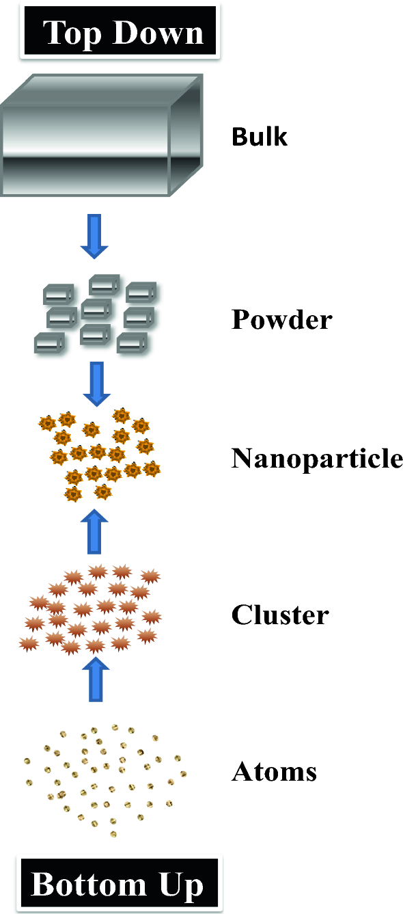

## 

## 

## (A). Physical Vapour Deposition(PVD):

Physical Vapor Deposition (PVD) is a key technique used to coat materials like metal, glass, ceramics, and plastics with thin films to enhance hardness, wear, and corrosion resistance. It's widely applied in industries like electronics, automotive, medical devices, and decorative goods due to its durability, performance benefits, and eco-friendly nature. By understanding methods like sputtering, ion plating, and thermal evaporation, engineers can choose the best process for their needs.

The materials of interest are evaporated and hence, the atoms or molecules are in gas phase. The gas phase atoms or molecules are used to obtain the nanostructured materials in any one of the methods, namely,

1. Evaporation

2. Sputtering

3. Ion plating

4. Laser ablation

Evaporation

Evaporation is a basic yet essential PVD method where a material—called the source material—is heated in a vacuum until it turns into vapor. This vapor then travels through the vacuum chamber and condenses onto a cooler surface, forming a thin coating. Commonly used for metals, alloys, and organic materials, this technique ensures a clean and uniform film thanks to the vacuum environment, which minimizes contamination. Heating is typically done using a tungsten filament or an electron beam.

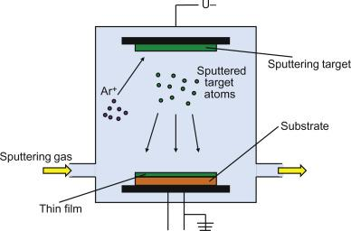

## PVD Advantages & Disadvantages

• Environment friendly then paint & electroplating.

• More than one PVD technique can be used for coating.

• Usually topcoats are not required.

• Good strength and durability.

Disadvantages

• Cooling systems are required.

• Mostly high temperature and vacuum control needs skill & experience.

• PVD coated materials has no chemical interaction with the surface

## (B). Chemical Vapor Deposition (CVD)

Chemical Vapor Deposition (CVD) is a widely used technique for synthesizing high-quality nanomaterials, such as carbon nanotubes (CNTs), graphene, and various metal and metal oxide nanoparticles. The process involves the decomposition of volatile precursors in the gas phase, leading to the formation of a solid material on a substrate.

In a typical CVS process metal organic precursor is inserted into the hot wall reactor at controlled rate. For producing halide, nitride, carbide, or metal oxide nanoparticles, the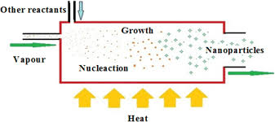 reaction chamber is filled with respective reactive gas precursors. If a mixture of gas reactants is introduced in the reactor, the energy (produced from resistant heating, laser, or plasma heating) can cause chemical reactions among them. For producing oxides, chlorides are the most popular precursors owing to their characteristically low vaporization temperatures and low cost. A common chemical reaction taing place inside the reactor involving chlorides is as follows:21

SnCl4 (g) + 2H2O (g) → SnO2 (s) + 4HCl (g)

## Avantage & Disadvantages of CVD

Advantage

1. high growth rates possible

2. can deposit materials which are hard to evaporate

3. good reproducibility

4. can grow epitaxial films

Disadvantages

1. high temperatures

2. complex processes

3. toxic and corrosive gasses

## (C). PULSED LASER VAPOUR DEPOSITION (PLVD)

Pulsed-laser vapour deposition (PLVD) has gained a great deal of attention in the past few years for its ease of use and success in depositing materials of complex stoichiometry.

PLVD was the first technique used to successfully deposit a superconducting YBa CuO thin film. Since that time, many materials that are normally difficult to deposit by other methods, especially multi-element oxides, have been successfully deposited by PLVD.

Synthesis of Buckminster fullerenes and nanopowders have also been reported by using PLVD.

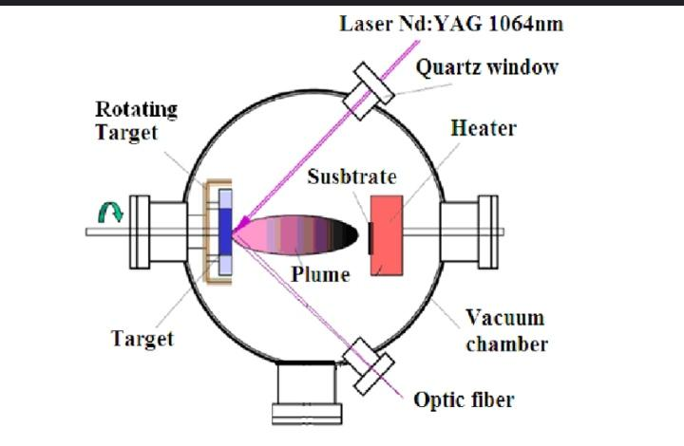

Mechanisms

Pulsed Laser Deposition (PLD) involves complex processes despite a simple setup.

A high-energy laser hits a solid target, ejecting material as a plasma plume. This material travels to a heated substrate, forming a thin film.

The process has four key stages:

1. Laser strikes target

2. Material ablates and forms a plume

3. Plume deposits on substrate

4. Film nucleates and grows

PLD Advantages:

1.Simple – Laser hits target and makes a matching film.

2.Flexible – Works with many materials and gases.

3. Low cost – One laser can run many setups.

4. Fast – Makes good films in 10–15 minutes.

5.Scalable – Good for large-scale production.

## (D). Sol-gel method

• The sol gel process is a wet chemical technique i.e., chemical solution deposition technique used for the production of high purity and homogeneous nanomaterials, particularly metal oxide nano particles.

• The idea behind sol-gel synthesis is to "dissolve" the compound in a liquid in order to bring it back as a solid in a controlled manner.

• The starting material from a chemical solution leads to the formation of colloidal suspensions known as 'sol'.

• Then the sol evolves towards the formation of an inorganic network containing a liquid phase called the 'gel'.

• The removal of the liquid phase from the sol yields the gel.

• The particle size and shape are controlled by the sol/gel transitions.

• The thermal treatment (firing/calcinations) of the gel leads to further poly condensation and enhances the mechanical properties of the products, i.e., oxide nanoparticles.

The precursors for synthesizing the colloids are metal alkoxides and metal chlorides.

• The starting material is processed with water or dilute acid in an alkaline solvent.

• The material undergoes a hydrolysis and poly condensation reaction which leads to the formation of colloids.

• The colloid system composed of solid particles dispersed in a solvent contains particles of size from Inm to Imm.

• The sol is then evolved to form an inorganic network containing liquid phase (gel).

The schematic representation of the synthesis of nanoparticles using the sol gel method is shown in Fig.

• The sol can be further processed to obtain the substrate in a film, either by dip coating or spin conting, or cast into a container with desired shape or powders by calcinations.

• The chemical reaction which takes place in the sol gel metal alkoxides M (OR), during the hydrolysis process and condensation is given below:

M-O-R+H₂O M-OH + R-OH(Hydro) M-O-M+ R-OH M-O-H + R-O-M(Cond)

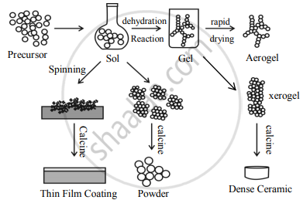

## Advantages

1. The sol-gel method is an interesting, cheap and low temperature technique which is used to produce a range of nanoparticles with controlled chemical compositions.

2. One can produce the aero gel, a highly porous material like glass and glass ceramics, at a very low temperature by controlling the process parameters.

3.The sol gel derived nanoparticles finds wide spread applications in various fields like optics, electronics,

## Disadvantage

1. Energy space,bio sensors and drug delivery.

2. Controlling the growth of the particles is difficult.

3. Stopping the newly formed particles from agglomeration is also difficult.

# (2.6). Applications of Nanotechnology

Nanotechnology offers a vast array of potential applications across electronics, communication, biology, materials science, and environmental management. Some of the most promising areas include

## 1. Junctionless Nanowire Transistors

These are a new type of transistors (tiny electronic switches) made using nanowires. Unlike traditional transistors, they don’t have any junctions, which makes them:

Easier to build

More energy-efficient

Better at handling smaller sizes in chips

They work like resistors that can be controlled using a gate to turn the current on or off.

## 2. Next-Gen Computer Chips

Nanomaterials are helping to build the future of computers by making chips:

Faster

Smaller

More power-efficient

Materials like carbon nanotubes and graphene are being used to make extremely tiny transistors that can boost speed and reduce energy use.

## 3. Pollution Control

Nanomaterials can help clean the environment. They can:

Soak up harmful substances from water, air, or soil (adsorption).

Break down pollutants using light (photocatalysis).

Filter out contaminants using special nanomembranes.

Examples include carbon nanotubes, graphene, metal oxides like TiO₂, and metal nanoparticles.

## 4. Sunscreen

Many sunscreens now use zinc oxide or titanium dioxide nanoparticles. These:

Protect skin from harmful UV rays

Don’t leave a white cast on the skin (because of their tiny size)

Are more effective and look better when applied

## 5. Sensors

Nanosensors are super small devices that can detect changes in temperature, pressure, chemicals, or even biological signals. They’re useful in:

Healthcare (diagnosis)

Environment (pollution tracking)

Engineering (detecting damage in structures)

They come in different types: chemical, mechanical, biological, and magnetic.

## 6. HDTV Screens (Phosphors)

Nanomaterials are used in phosphors, which give off light in TV screens. They help create brighter, sharper images by producing red, green, and blue colors more precisely.

## 7. Medicine and Healthcare

Drug Delivery: Nanoparticles can deliver drugs directly to diseased cells, improving effectiveness and reducing side effects.

Cancer Treatment: Gold nanoparticles and liposomes are used for targeted cancer therapy.

Imaging and Diagnostics: Quantum dots and magnetic nanoparticles enhance imaging techniques like MRI.

Antibacterial Agents: Silver nanoparticles are used in wound dressings and coatings for their antimicrobial properties.

## 8. Construction and Materials

Stronger Materials: Carbon nanotubes and nanocomposites make materials stronger and lighter.

Self-cleaning Surfaces: Nano-coatings mimic lotus leaf effect for dust- and water-repellent surfaces.

Fire-resistant Coatings: Nanomaterials can improve flame resistance.

## 9. Textiles and Consumer Products

### Smart Fabrics:

Nanocoatings make textiles stain-resistant, water-repellent, or UV-protective.

### Cosmetics:

Nanoparticles are used in sunscreens and anti-aging creams for better skin penetration.

### Food Packaging:

Nanomaterials increase shelf life and detect spoilage.

## 10. Environment

### Water Purification:

### Nanofilters can remove contaminants and pathogens from water.

### Air Purification:

Nanomaterials help in breaking down pollutants in the air.

### Waste Treatment:

Nanoparticles assist in degrading hazardous substances.

Chapter- 3

Climate change: A serious Problem

## **(3.1). Definition of Climate Change**

## **Climate change** refers to significant, long-term changes in the Earth’s climate patterns—especially temperature, precipitation, wind patterns, ocean currents, and atmospheric composition. While some fluctuations in the climate have occurred naturally over thousands or even millions of years, **the rapid changes observed over the last century are primarily driven by human activity**.

Climate is the usual weather in a place over many years—typically 30 or more. There are many types of climates across the Earth.Warmer regions are near the equator, where the Sun’s rays hit directly. Polar regions are colder because sunlight there is less direct.

In the late 1800s and early 1900s, German scientist Wladimir Köppen classified world climates based on temperature, rainfall, and when rain falls. He also considered a region's latitude, or its position north or south of the equator.

Climate experts have divided the Earth into around five major climate types. These can be described as:

* Tropical
* Dry
* Temperate
* Continental
* Polar.

1. Tropical – These regions are hot and humid all year. Temperatures stay above 64°F (18°C), and they get over 59 inches of rain annually.

2. Dry – These areas receive very little rain because the air loses moisture quickly. The climate is mostly arid or semi-arid.

3. Temperate – This zone has warm, humid summers with frequent thunderstorms, and winters are mild and not too cold.

4. Continental – Summers here range from warm to cool, but winters are harsh with freezing temperatures, snowstorms, and strong winds. It can get as cold as -22°F (-30°C) or lower.

5. Polar – These are the coldest regions. Even during summer, temperatures don’t go above 50°F (10°C).

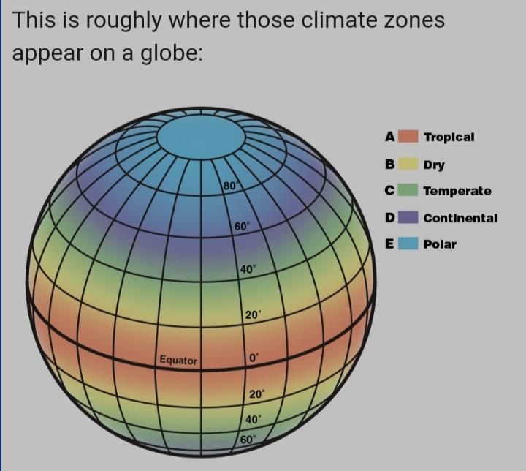

# (3.2). **Importance of Understanding Climate Change**

## Understanding climate change is critical because it influences every aspect of life on Earth—from natural ecosystems to human societies, economies, and health.

### **(a). Environmental Impact**

**• Melting Ice Caps & Glaciers:**

As global temperatures rise, glaciers and polar ice sheets are melting at alarming rates. This contributes to **sea level rise**, threatening low-lying coastal areas with floods and erosion.

**• Extreme Weather Events:**

Warmer air holds more moisture, intensifying storms like hurricanes and typhoons. Droughts, wildfires, floods, and heatwaves are becoming more frequent and destructive.

**• Ocean Warming & Acidification:**

Oceans absorb most of the heat and a large portion of CO₂. This leads to coral bleaching and disrupts marine life.

### **(b). Biodiversity Loss**

**• Habitat Disruption:**

Climate shifts force species to migrate, adapt, or face extinction. Some species, especially those in fragile ecosystems like the Arctic or tropical rainforests, cannot survive rapid changes.

**• Ecosystem Collapse:**

When key species (like pollinators or predators) disappear, entire ecosystems can become unbalanced, affecting food chains and natural services like water purification and soil fertility.

### **(C). Human Health**

**• Disease Spread:**

Warmer climates allow disease-carrying organisms like mosquitoes to thrive in new regions, spreading illnesses such as malaria, dengue, and Zika virus.

**• Heat-Related Illnesses:**

Heatwaves increase cases of dehydration, heatstroke, and cardiovascular stress—especially among the elderly and children.

**• Air Quality Deterioration:**

Higher temperatures lead to the formation of ground-level ozone and worsen pollution, triggering respiratory diseases like asthma.

### **(d). Economic Consequences**

**• Agricultural Losses:**

Crops are sensitive to temperature, rainfall, and soil quality. Droughts or floods can destroy harvests, raising food prices and triggering shortages.

**• Infrastructure Damage:**

Extreme weather damages roads, bridges, power lines, and buildings. Recovery and adaptation require massive financial investments.

**• Livelihood Disruption:**

Climate change affects sectors like farming, fishing, and tourism, leading to job losses, migration, and increased poverty in vulnerable areas.

### **(e). Water and Food Security**

**• Water Scarcity:**

Changes in rainfall and glacier melt patterns reduce the availability of freshwater, especially in arid regions or where rivers depend on mountain ice.

**• Food Production Risk:**

Unpredictable growing seasons, loss of fertile land, and new pests and diseases impact food availability and nutrition.

**• Global Hunger Threat:**

According to the UN, climate change could push millions into food insecurity, especially in low-income countries.

### **(f). Global Policy and Sustainability**

**• International Cooperation:**

Climate change knows no borders. Agreements like the **Paris Agreement** bring nations together to limit global warming to below 2°C.

**• Energy Transition:**

Shifting from fossil fuels to **renewable energy** (solar, wind, hydro, etc.) is key to reducing emissions.

**• Sustainable Practices:**

Urban planning, green infrastructure, sustainable farming, and conservation efforts help societies adapt and thrive in changing conditions.

# (3.3). Scientific evidence and global trend :

Scientific evidence clearly shows that Climate change, mainly caused by human activities like burning fossil fuels, is heating the planet. As a result, ice caps and glaciers are melting, and sea levels are rising. Evidence includes higher global temperatures, shrinking ice sheets, and faster sea level rise.

## (a). Melting Ice caps :

### Greenland and Antarctica:

Since 1992, both have steadily lost ice, driving sea level rise. Greenland sheds ~175 billion metric tons/year; Antarctica loses over 90 billion.

### Glaciers Worldwide:

Glaciers are retreating globally—from the Alps and Himalayas to the Andes, Rockies, Alaska, and Africa.

### Arctic Sea Ice:

Arctic sea ice is shrinking rapidly, declining by over 10% per decade.

## (b). Rising Sea Levels:

• Sea levels have gone up by about 8–9 inches (21–24 cm) since the year 1880.

• This rise is mostly due to melting ice and warmer oceans expanding.

• The speed of sea level rise has increased sharply in the last 20 years.

• By the year 2100, sea levels could go up:

At least 1 foot (0.3 meters)

Possibly as much as 6.6 feet (2 meters), depending on how much greenhouse gases we release.

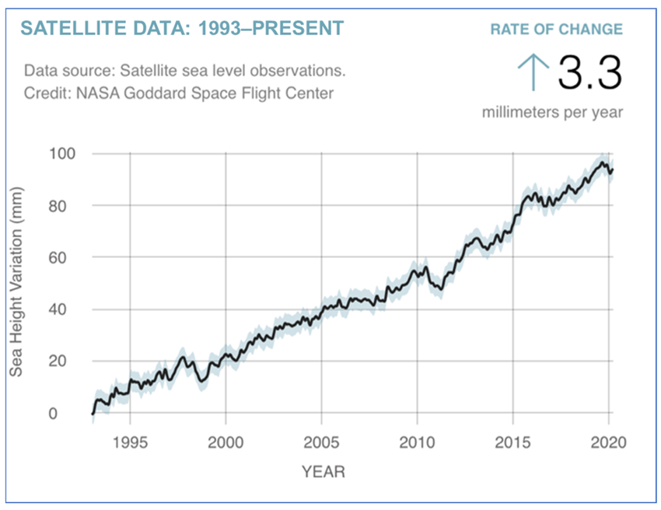 ( Global sea level rise )

# (3.4).Scientific Proof from Trusted Organizations:

## NASA:

Satellite data and other tools from NASA clearly show the Earth is warming, with ice melting and sea levels going up.

### NOAA:

NOAA reports confirm climate change effects like higher global temperatures, melting glaciers, and rising seas

Effects on Ecosystems and Human Communities

• Higher sea levels put coastal towns, natural habitats, and buildings at risk.

• Melting glaciers affect freshwater supplies and local ecosystems.

• Shifts in temperature and rainfall are changing where plants and animals live and when they grow, migrate, or reproduce.

# (3.5). Causes of climate change

## (A). Natural Causes of Climate Change:

## 1. Solar Variation:

The amount of solar energy reaching Earth varies over time. Changes in sunspot activity can influence global temperatures

## 2. Volcanic Activity:

Large volcanic eruptions release ash and gases like sulfur dioxide into the atmosphere, reflecting sunlight and temporarily cooling the planet.

## 3. Orbital Changes:

The Earth's orbit and tilt (Milankovitch cycles) shift over thousands of years, altering the distribution of solar energy and triggering ice ages and warm periods.

## 4. Ocean Currents. Ocean circulation patterns can influence global weather and climate patterns temporarily.

# (B). Human-Induced Causes:

## 1. Greenhouse Gas Emissions:

Burning fossil fuels like coal, oil, and gas releases carbon dioxide (CO₂) and other greenhouse gases, trapping heat in the atmosphere.

## 2. Deforestation:

Trees absorb CO₂, so cutting them down reduces the planet’s ability to regulate CO₂ levels.

Also releases stored carbon from trees into the atmosphere.

## 3. Industrialization & Agriculture:

Factories, transport, and large-scale agriculture release methane, nitrous oxide, and other heat-trapping gases. Manufacturing, mining, and cement production release various greenhouse gases.Industrial processes often involve chemical reactions that emit heat-trapping gases.

These human activities have significantly enhanced the greenhouse effect, leading to global warming, which is a major driver of broader climate change.

## 4. Agriculture

Produces methane (from livestock digestion) and nitrous oxide (from fertilizers).

Paddy fields also emit significant methane.

## 5. Waste Management

Decomposing organic waste in landfills emits methane.

Poor waste treatment systems in urban areas contribute to emissions.

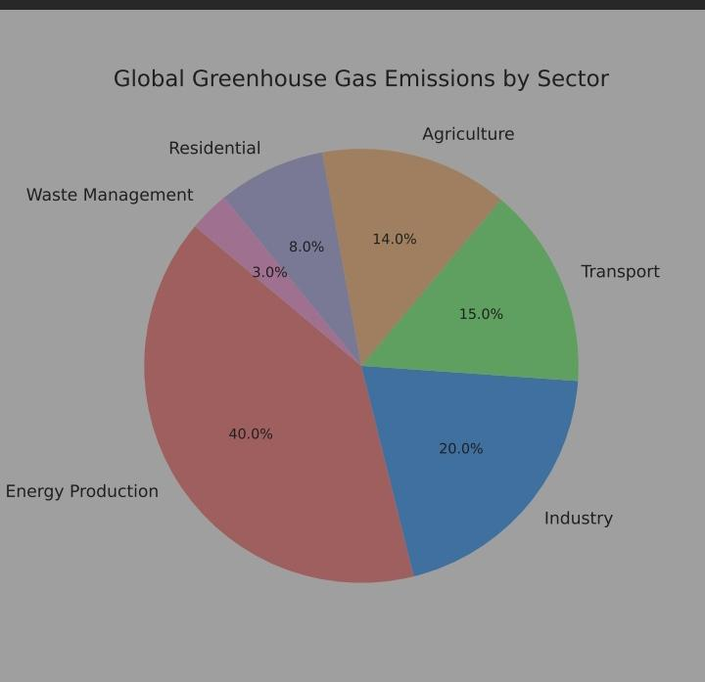

# (3.6). Climate change:A global challenge

## (A).Green House Gases

# Some gases found naturally in the atmosphere—like carbon dioxide (CO₂) and water vapor (H₂O)—trap heat and create a greenhouse effect.

# Human activities, especially burning fossil fuels such as oil, coal, and natural gas, are increasing CO₂ levels in the air. Today’s CO₂ concentration is the highest in the last 650,000 years.

# According to the Fourth Assessment Report by the Intergovernmental Panel on Climate Change (IPCC) “most of the rise in global temperatures since the mid-20th century is very likely caused by the increase in human-produced greenhouse gases”.

Carbon pollution caused by human activities is the main reason for climate change. As a result, temperatures are rising, ice is melting, and sea levels are increasing.This extra heat is also changing rainfall and wind patterns.

Another effect is the acidification of oceans, as they absorb large amounts of CO₂.When CO₂ dissolves in water, it forms acid, which is harming marine life.

Scientists believe that if pollution is reduced, we can avoid major future threats.

## (i). Main Greenhouse Gases

The gases in Earth's atmosphere that are most responsible for climate change are called greenhouse gases. The main ones are:

1. Carbon Dioxide (CO₂)

2. Methane (CH₄)

3. Nitrous Oxide (N₂O). 4.CFCs

These three gases make up the largest share of greenhouse gas emissions and play the most significant role in global warming.

## (ii). Percentage Share in Greenhouse Gas Emissions

Different greenhouse gases are present in the atmosphere in varying amounts. Their contribution to total global emissions is approximately:

1. Carbon Dioxide (CO₂) – about 76%

2. Methane (CH₄) – about 16%

3. Nitrous Oxide (N₂O) – about 6%

4. Fluorinated Gases – about 3%

CO₂ has the largest share, mainly from the burning of fossil fuels and deforestation.

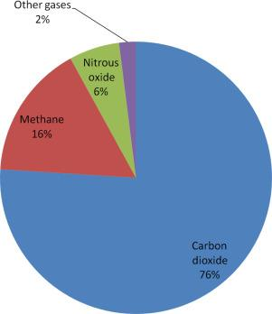

## (iii). Contribution to Climate Change

It’s not just the amount of each gas that matters, but also their impact on the atmosphere.

Here’s how much each gas contributes to global warming:

• CO₂ – about 64% of the warming effect

• Methane (CH₄) – about 16%

• Nitrous Oxide (N₂O) – about 7%

# 2. Major Sources of Greenhouse Gas Emissions

## (a). Fossil Fuels

Burning fossil fuels like coal, oil, diesel, and gas produces the highest amount of greenhouse gases.

It contributes to more than 75% of total emissions. This includes power generation, vehicles, factories, and heating systems.

## (b). Deforestation

When trees are cut down, they can no longer absorb CO₂, and the carbon stored in them is released into the atmosphere.

This accounts for about 25% of global emissions.

## (C). Agriculture

• Farming and livestock also release significant greenhouse gases, especially:

• Methane – from the digestive systems of animals like cows

• Nitrous Oxide – from chemical fertilizers and soil.

## (d). Industry

Industries release nitrous oxide and various fluorinated gases, which are particularly harmful to the climate due to their long-lasting effects.

# 3. Effect of Green House Gases

## (a). Global Warming: The temperature of the Earth is gradually increasing.This is caused by gases released from vehicles, factories, and fuels.These gases are called greenhouse gases.Examples include carbon dioxide and methane.

## (b). Ozone Layer Depletion:

The ozone layer protects us from the sun’s harmful rays.When this layer becomes thin, UV rays reach the Earth directly.

This can cause skin diseases and climate change.CFCs and other gases damage the ozone layer.

## (c). Smog and Air Pollution:

Smog is formed by mixing smoke and fog.

It is caused by vehicles, factories, and burning materials.It leads to breathing problems and eye irritation.

## (d). Acidification of Water Bodies: When gases mix with rain, acid rain occurs.This rain makes rivers, lakes, and ponds acidic.It harms the living organisms in the water

## 4.Solution:

• Reducing greenhouse gases starts with using clean energy like solar and wind instead of fossil fuels.

• Saving electricity and improving energy use at home and in industries also help.

• Planting trees and protecting forests is important because they absorb carbon dioxide.

• In farming, eco-friendly methods and better livestock management can reduce harmful gases.

• Recycling waste and using less landfill space lowers methane emissions.

• Choosing electric vehicles or public transport instead of fuel-powered ones cuts pollution.

• Industries should use cleaner technologies, and global cooperation is essential to fight climate change effectively.

(B). Global Warming:

Global warming is the ongoing increase in global average temperature that is causing climate change. The Earth's temperature is slowly increasing. The main reason is the gases released from cars, factories, and burning fuel, which are heating up the air.

Global warming will cause the glaciers on high mountains and on land in

the polar regions to melt.

Global warming will lead to sea level

rise. When glaciers melt and transform into water, the resulting water will flow into the oceans, leading to an increase in sea levels. This rise in sea levels could potentially submerge small island nations built on coral atolls and may also lead to flooding in other regions.

Global warming will make the

weather unstable.Outdoor activities

could become a hardship.Weather becomes hotter and hotter

with global warming.

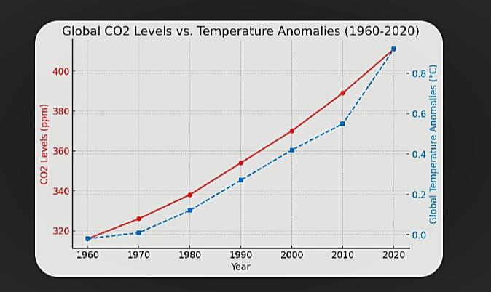

( a graph showing the correlation between global CO₂ levels and temperature anomalies from 1960 to 2020.)

# (3.7). Human Activity and their Impact

## (i). Industrial and Emissions

Industrial emissions, mainly from burning fossil fuels and processes like cement, steel, and chemical production, release greenhouse gases such as CO2, methane, and nitrous oxide. These gases trap heat in the atmosphere, causing global warming, extreme weather, rising sea levels, and ocean acidification. Industrial activities also harm human health through air pollution. Sectors like cement, steel, and chemical manufacturing are major contributors to these emissions.

## (ii). Deforestation and land use change

Deforestation, the removal of forests for other purposes like farming, urbanization, or infrastructure, has serious consequences, including higher greenhouse gas emissions, soil degradation, and loss of biodiversity. It disrupts the natural water cycle, lowers soil fertility, and fragments habitats. The main causes of deforestation are human activities such as logging, farming, and the expansion of cities, with rising demand for food, particularly from animal farming, being a key driver.

Land use changes like farming, urban growth, and infrastructure release stored carbon and destroy habitats, harming climate and biodiversity. Reforestation and sustainable farming help reduce these impacts.

## (iii). Urbanization and Pollution:

Urban growth increases factories, traffic, and waste, which pollute air, water, and land. This harms human health, damages ecosystems, and worsens the environment overall.

### Air Pollution

More vehicles and industries increase harmful emissions, worsening air quality and health.

### Water Pollution

Urban waste and chemicals contaminate water bodies, harming aquatic life and human use.

### Land Degradation

City growth causes deforestation, soil damage, and waste buildup.

### Noise & Light Pollution

Traffic and artificial lights disturb humans and wildlife.

### Health & Ecosystems

Pollution from cities leads to diseases and weakens natural ecosystems.

# (3.8). Consequences of Climate Change

## (a). Environmental Effect.

### Biodiversity Loss:

## Climate change alters habitats, causing species shifts, extinctions, and ecosystem imbalance

### Ocean Acidification

## CO₂ absorption lowers ocean pH, harming corals, shellfish, and marine life.

### Sea-Level Rise

## Melting ice and warmer oceans raise sea levels, threatening coasts and habitats.

### Extreme Weather

## Climate change increases storms, floods, droughts, and heatwaves, causing destruction and displacement.

### Other Impacts

## Deforestation, pollution, and land degradation worsen environmental damage.

## (b). Social and Economic Effect

### Rising Poverty and Inequality:

The effects of climate change hit low-income communities hardest, deepening social and economic divides.

### Forced Relocation:

Harsh weather and environmental changes push people to move, increasing displacement and resource tensions.

### Infrastructure Challenges:

Climate impacts damage essential systems like transport and water supply, creating financial and logistical burdens.

### Job Market Disruption:

Shifts in climate affect farming and other sectors, leading to job loss and income uncertainty.

### Social Tensions:

Resource shortages and economic stress from climate impacts may fuel unrest and conflict.

## (C). Health and Food Sequrity

### Heat Illnesses:

Rising heat causes conditions like heatstroke and exhaustion.

### Respiratory Issues:

Air pollution worsens asthma and other lung diseases.

### Waterborne Diseases:

Warmer, scarce water increases diseases like cholera.

### Vector-Borne Diseases:

Mosquitoes and other carriers spread further, raising disease risks.

### Mental Health:

Climate stress leads to anxiety, depression, and trauma.

Lower Crop Production

Shifting climate patterns reduce harvests and affect food supply.

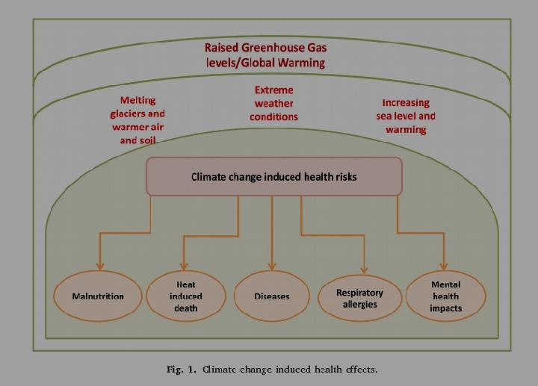

### Rising Food Costs

Scarcity and supply issues drive up prices, hitting the poor hardest.

### Malnutrition Risk

Less access to healthy food increases malnutrition, especially in vulnerable groups.

### Dietary Shifts

Food changes may lead to poor nutrition and deficiencies.

### Fisheries at Risk

Warming seas and acidification harm fish stocks and coastal food sources

# (3.9). Climate change in India

India is facing the growing impacts of climate change. From hotter days to unpredictable rains, the environment is shifting in ways that directly affect people's lives and livelihoods. Rural and urban areas alike are seeing the consequence.

## (i). Current Scenario and statistics:

## 1. Temperature Rise & Extreme Weather:

India’s temperature rose 0.7°C (1901-2018), with Delhi expected to increase by 5.3°C. Heatwaves and extreme weather are causing damage.

### 2. Agriculture & Water:

Changing rainfall and rising temperatures disrupt farming and water availability, with droughts and water scarcity affecting 40% of the population by 2050.

### 3. Coastal Vulnerabilities:

Rising sea levels threaten coastal areas, causing erosion and saltwater intrusion.

### 4. Health Impacts:

Climate change worsens heatstroke, respiratory diseases, and vector-borne illnesses like malaria and diarrhea.

### 5. Vulnerability & Adaptation:

India’s geography and reliance on agriculture make it vulnerable. Adaptation is needed through better water management and climate-resilient farming.

### 6. Mitigation Efforts:

India aims for net-zero emissions by 2070, expanding renewable energy and reducing emissions.

## (2). Vulnerable Area and communities :

India is facing serious threats from climate change, especially in certain regions and communities. States like Assam, Andhra Pradesh, Maharashtra, Karnataka, and Bihar are among the most affected, experiencing disasters such as floods, droughts, and heatwaves.

## (a). Vulnerable Region

### Coastal Areas:

Rising sea levels and stronger storms are affecting the livelihoods and infrastructure of coastal regions.

### Northeast India:

Due to heavy rainfall and hilly terrain, this region is highly prone to floods and landslides.

### Central and Southern India:

Irregular rainfall and increasing temperatures are making droughts and heatwaves more common here.

### Urban Areas:

Overcrowded cities with poor planning face greater risks from heatwaves, flooding, and health-related issues.

(b).Vulnerable Communities:

### Villages and Farmers:

Changing weather affects farming, making it hard for rural people to earn and get enough food.

### Poor and Marginalized Groups:

People with fewer resources—like tribal and Scheduled Caste communities—struggle more to cope with climate impacts.

### People Dependent on Nature:

Tribal groups who rely on forests and water are more affected by deforestation and water shortages.

### Coastal Residents:

Those living near the sea face risks from rising water levels, erosion, and storms.

Elderly and Children:

They are more vulnerable to heat and diseases, making their health more at risk.

# (3.10). Government Policy and Response:

India has acknowledged the urgent need to address climate change and has implemented various policies and actions to reduce greenhouse gas emissions and enhance sustainability. Here are the key aspects of the government’s response:

## 1. National Action Plan on Climate Change (NAPCC)

• Launched in 2008, the NAPCC serves as the overarching framework for climate action in India.

• It consists of 8 national missions that address different sectors like energy efficiency, solar energy, sustainable agriculture, and water conservation.

## 2. Bharat Stage (BS)

Emission Standards:

India moved directly from BS-IV to BS-VI in 2016 to reduce vehicle emissions and meet global standards.

## 3. National Clean Energy Fund (NCEF)

Established in 2010, it funds clean energy projects, sourced from a cess on coal.

## 4. International Solar Alliance (ISA)

Launched by India and France in 2015 to promote global solar energy cooperation.

## 5. Targets Under the Paris Agreement

• India has committed to reducing its emissions intensity (emissions per unit of GDP) by 33-35% by 2030, compared to 2005 levels.

• The country aims to increase the share of non-fossil fuel-based power capacity to 40% by 2030.

## 6. Renewable Energy Development

• India has set ambitious renewable energy goals, aiming for 500 GW of non-fossil fuel-based capacity by 2030.

• The government has significantly invested in solar, wind, and hydro energy, with a target of achieving 175 GW of renewable energy by 2022, and 500 GW by 2030.

• The National Solar Mission has played a crucial role in scaling up solar energy projects.

## 7. Clean Energy Initiatives

• India has launched the National Green Hydrogen Mission and is expanding its wind energy capacity.

• Policies such as Viability Gap Funding (VGF) have been used to support offshore wind projects and enhance renewable energy projects' financial feasibility.

## 8. Energy Efficiency

• India has a National Mission for Enhanced Energy Efficiency (NMEEE), focusing on improving energy efficiency in industries, buildings, and other sectors.

• The Bureau of Energy Efficiency (BEE) promotes energy-saving schemes such as the Perform, Achieve, and Trade (PAT) scheme and the Energy Conservation Building Code (ECBC).

## 9. Coal and Fossil Fuel Dependency

• Despite the growing renewable energy push, India remains heavily dependent on coal for energy production, with a government plan to add 80 GW of coal power capacity by 2031-32.

• The government has adopted the National Electricity Plan 2023, which has proposed a halt on new coal power plant additions, though existing capacity expansion continues.

## 10. International Climate Finance

• India emphasizes the need for climate finance and technology transfer from developed countries to meet its climate targets, arguing that as a developing nation, it requires support to mitigate and adapt to climate impacts.

• The Indian Renewable Energy Development Agency (IREDA) and other bodies are focusing on mobilizing investment for renewable energy.

# 11. Challenges

• Energy Demand and Supply Gap: Despite progress, the growing demand for energy due to rapid industrialization and urbanization is outpacing the growth in renewable energy.

### • Regional Disparities:

Some regions, particularly southern states, are leading in renewable energy, while others lag behind.

### • Fossil Fuel Consumption:

India has seen an increase in the domestic production and import of coal and fossil gas to meet short-term energy demands, increasing reliance on fossil fuels.

# 12. India's Climate Pledge (Net Zero)

India has set a target to achieve net-zero emissions by 2070, marking a significant commitment but further raising concerns about its capacity to meet more immediate targets.

# 13. Future Directions

• The government needs to scale up its policy and actions to align with the 1.5°C global warming target.

• International cooperation, along with stronger domestic policies on renewable energy, energy efficiency, and emission reductions, will be critical for India to meet its climate commitments.

• India's response to climate change has been multifaceted, balancing economic development needs with environmental sustainability, but further commitment and more robust action are needed to meet its climate goals.

Chapter- 4

# 4. Nano Solutions for a Warming Planet: Mitigating Climate Change with Nanotechnology

## (4.1). Role of Nanoscience in Combating Climate Change

## (i). Nanotechnology in Carbon Capture and Storage (CCS)

• Nanotechnology enables more efficient capture and storage of carbon dioxide from the atmosphere.

• Nanostructured membranes help separate CO₂ from other gases.

• Nanoporous materials like zeolites and Metal Organic Frameworks (MOFs) possess high CO₂ absorption capacity.

## (ii). Nanoscience in Renewable Energy Sources

• Nanotechnology enhances the efficiency and affordability of solar, wind, and bioenergy sources.

• Nanomaterials improve the light absorption and efficiency of solar panels.

• Nano-coating in thin-film solar cells reduces production costs.

• Nano-composites make wind turbine blades lighter and more durable.

## (iii). Energy Storage and Batteries

• Nanomaterials enable faster-charging batteries with higher storage capacity.

• Materials like graphene improve supercapacitor performance.

## (iv). Nanotechnology in Pollution Control and Water Purification

• Nanoscience is also useful in pollution reduction and resource purification.• Nano-catalysts help neutralize atmospheric pollutants.

• Nanofiltration removes heavy metals, pathogens, and toxic substances from water.

• This minimizes environmental damage and ensures public health safety.

## (v). Sustainable Agriculture

### Nano-fertilizers and Pesticides

Traditional fertilizers and pesticides often lead to nutrient loss, soil degradation, and water pollution.

• Releasing nutrients in a controlled and targeted manner.

• Enhancing the uptake of nutrients by plants.

• Reducing the quantity needed and minimizing environmental runoff.

### Water-Efficient Farming Using Nanotech

Water scarcity is a major challenge in agriculture. Nanomaterials like nano-clays and hydrogels can retain moisture in soil and release it slowly to plants. Additionally, nanosensors help in precision irrigation by

Monitoring soil moisture levels.

## (vi). Smart Materials

### Self-Cleaning Surfaces

Use nano-coatings (like TiO₂)

Break down pollutants and smog

Reduce water and chemical use

Lower maintenance energy

Improve urban air quality

Support climate goals indirectly

### Lightweight Materials for Transport

• Use nanocomposites for lighter vehicles

• Reduce fuel use and emissions

• Boost energy efficiency

• Maintain strength and safety

• Enable cleaner, greener transport

Nanotechnology deals with materials at a very small (nano) scale and helps in reducing pollution and protecting the environment.

## (4.2). Nanotechnology in Pollution Control and Environmental Protection

## (i). In Air Pollution Control

• Catalytic Converter: Nano-based catalysts reduce harmful gases from vehicles.

• Nano Filters: These filters remove tiny dust and pollutant particles from the air.

## (ii). In Water Purification

• Nanofibers: They clean water by removing harmful substances like bacteria and heavy metals.

• Graphene Oxide Filters: These filters absorb dangerous chemicals and make water safe.

## (iii). Green Construction Materials

Nano-materials make building materials stronger and help absorb air pollution. Some nano-coatings even clean the air around buildings.

## (4.3). Nano Materials for Extreme Weather

Nanoscience helps us adapt to changing climate by creating smart and strong materials.

## (i). Nano Materials for Extreme Weather

• Nano materials are used to make things more resistant to heat, cold, and storms.

• They are used in clothes, shelters, and tools to survive tough weather.

## (ii). Nanotech in Agriculture

• Smart Fertilizers: These release nutrients slowly and only when needed.

• Water Management: Nano materials help store and deliver water better during droughts.

## (iii). Climate-Adapted Buildings and Smart Coatings

• Buildings with nano-based materials stay cooler or warmer as needed.

• Smart Coatings reflect heat or absorb sunlight depending on the weather.

(4.4). Nanoscience and Renewable Energy

Nanoscience is helping make renewable energy more efficient and affordable.

## (i). Solar Energy

### Nano Solar Cells:

These are light, flexible, and capture more sunlight.

### Perovskite Solar Cells:

A new type of solar cell made with nano-materials; they are cheaper and work well even in low light.

## (ii). Wind Energy

Nanotech is used to make wind turbine blades stronger and lighter.

Nano coatings protect them from rust, heat, and wear.

## (iii). Hydrogen Fuel and Fuel Cells

Nano materials store hydrogen safely and improve fuel cell performance.

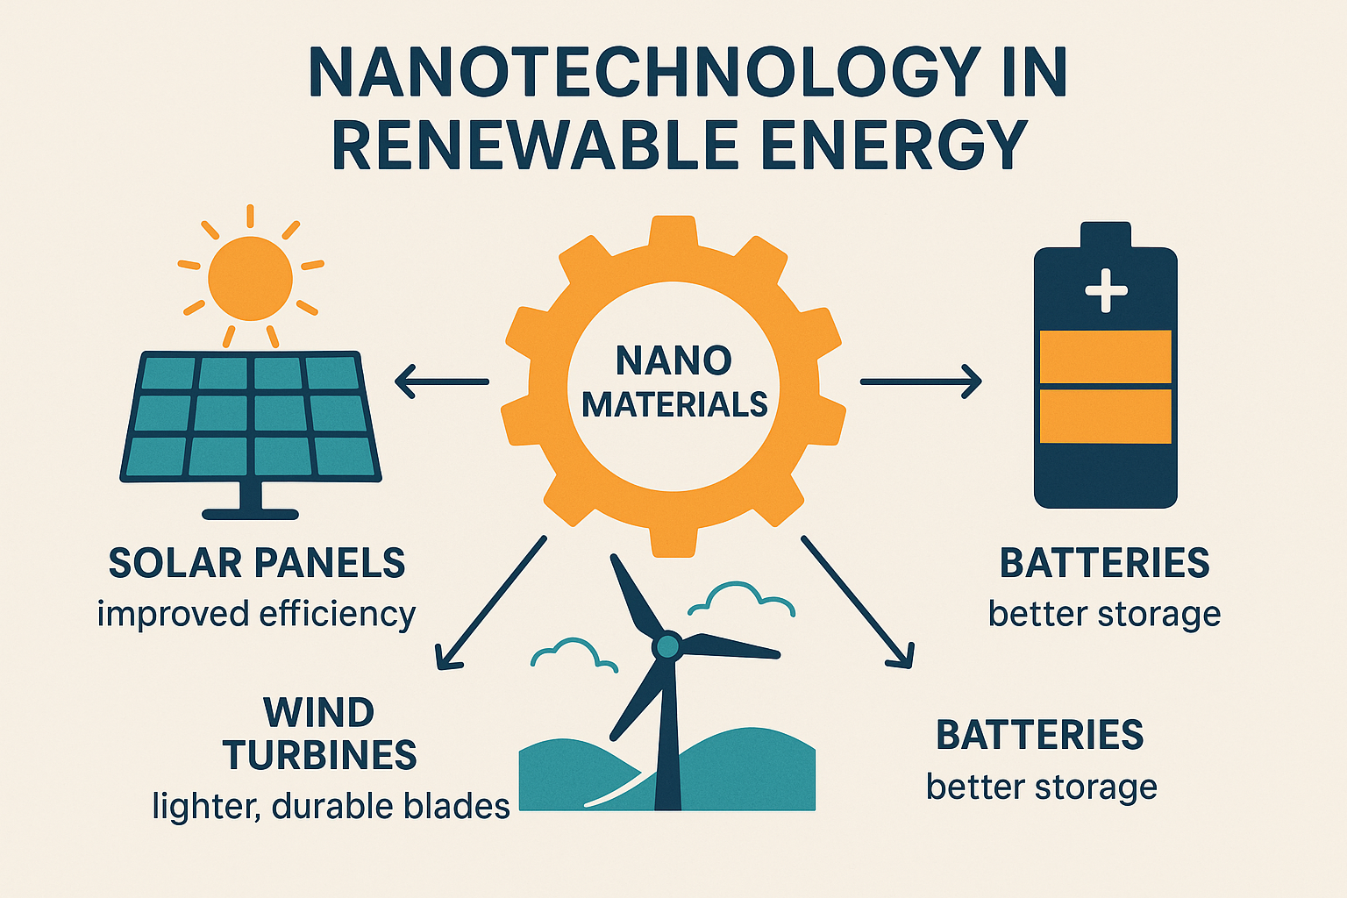

(4.5). Future Prospects of Nanoscience in Climate Change Mitigation

## (i). Emerging Technologies

Nanoscience is helping create new tools and materials that can fight climate change, such as:

### Capturing Carbon:

Tiny materials (like sponges at the nanoscale) can trap carbon dioxide from the air or factories more effectively.

Better Solar Panels: Nanomaterials are making solar panels cheaper and more efficient, helping us use more clean energy.

### Clean Fuels:

Special nanoparticles are used to produce fuels like hydrogen with less pollution.

### Reusing Waste Heat:

Some nanomaterials can turn waste heat from machines into electricity, saving energy.

### Energy-saving Coatings:

Nanotech paints and coatings help keep buildings cooler or warmer, cutting down on electricity use.

## (ii). Research and Development Trends

### Working Together:

Scientists from different fields are teaming up to create nanotech solutions for the environment.

### Eco-friendly Methods:

Researchers are finding safer and cleaner ways to make nanomaterials.

### Smart Design:

Computers and AI are being used to design better nanomaterials quickly.

### Learning from Nature:

Scientists are copying how nature works—like photosynthesis—to design energy-saving materials.

### Making it Real:

Work is being done to move these ideas from the lab to the real world, so they can be used widely.

## (iii). Policy and Regulations

### Clear Rules Needed:

Governments need to create clear rules about how nanomaterials should be used safely.

### Health and Environment Safety:

It’s important to check that these tiny materials don’t harm people or nature.

### Support for Green Innovation:

Countries are offering money and rewards to companies and scientists working on climate-friendly nanotech.

### Global Teamwork:

Countries must work together to share safe and smart ways of using nanotech, especially where climate change hits hardest.

### Making it Part of Climate Plans:

Nanoscience should be included in national and global climate strategies.

(4.6). Risks and Ethical Concerns of Nanotechnology

Nanotechnology is useful, but it also raises some health, environmental, and ethical issues that must be carefully considered.

## (i). Health and Environmental Impacts

Nanoparticles are very small and can enter the human body through air, water, or skin. They may cause harm to organs or cells, though full effects are still unknown.

In the environment, these particles may affect soil, water, animals, and plants. Long-term exposure could disturb ecosystems.

## (ii). Nano Waste Management

Industries using nanotechnology produce nano waste, which is hard to detect and manage. If released without care, it can pollute air, water, and soil, and may enter the food chain.

Safe disposal and recycling systems are still developing.

## (iii). Ethical and Social Concerns

• Privacy risks from tiny devices used for monitoring.

• Economic imbalance if only rich countries or people benefit.

• Job loss due to automation.

• Lack of regulation may lead to unsafe or unfair use.

(4.7). Policy and Governance: Nanoscience and Climate Change

Nanoscience can play a big role in fighting climate change, but for that, the right policies are needed.

If governments include nanotechnology in their climate plans, these technologies can be more effective.

## (i). Nanotechnology and Climate Policy

• Governments can support nano-based energy solutions, like affordable and efficient solar technology.

• Smart coatings and carbon capture using nanotech can be added to national climate strategies for better results.

## (ii). National and Global Regulations on Nanoscience

Nanotechnologies are tiny but powerful, so there should be rules to ensure they are used safely.

### Globally:

Organizations like WHO and UNEP are creating guidelines for the safe use of nanomaterials.

### Nationally:

Some countries have laws for labeling nano products, testing them for safety, and checking environmental impact. But in countries like India, stronger laws are still needed.

It is important that all countries work together to create a common policy so that nanotech is not misused.

## (iii). Sustainable Development Strategies for the Future

To use nanoscience for long-term, environment-friendly development, some strategies are needed

### Green Nanotechnology:

Develop nano products that are safe for nature and human health.

### Education and Awareness:

Teach people and researchers about the benefits and risks of nanotech.

### Local Use:

Bring low-cost nanotech solutions to rural and underdeveloped areas for clean energy, water, and farming.

### Encourage Innovation:

Support startups and researchers through funding and helpful policies.

Chapter-5

Conclusion and Recommendations

## (5.1). Summary of Key Points

• The paper has explored the causes of climate change, including human activities such as deforestation, industrialization, and carbon emissions, as well as natural factors that contribute to global warming.

• It has highlighted the significant environmental, social, and economic impacts of climate change, from rising sea levels to changes in weather patterns and biodiversity loss.

• Current mitigation and adaptation strategies were discussed, emphasizing international cooperation, sustainable energy sources, and policy reforms.

## (5.2). Potential of Nanoscience as a Climate Change Solution:

• Nanoscience is emerging as an innovative and powerful tool to address the climate crisis.

• The ability of nanomaterials to absorb atmospheric CO₂: Nanomaterials are being explored for their potential to capture and store carbon dioxide from the atmosphere, thereby helping to mitigate global warming.

• Nanomaterials enhancing solar energy efficiency: Nanotechnology can improve the efficiency of solar cells by utilizing nanomaterials that absorb more sunlight and convert it into energy more effectively, contributing to cleaner and more sustainable energy solutions.

## (5.3). Future Research Directions:

• Development of more sustainable and cost-effective nanomaterials

• Assessment of the long-term environmental impacts of nanomaterials

Study of the role of nanoscience in policy-making

• Analysis of the suitability of nano-based solutions in the context of developing countries

## (5.4). Future Recommendations

### (a). Stronger Global Policies:

Governments should strictly implement environmental regulations and commit to international agreements like the Paris Accord to limit global temperature rise.

### (b). Investment in Renewable Energy:

Governments and businesses should prioritize renewable energy sources such as solar and wind to reduce dependence on fossil fuels.

### (c). Public Awareness and Education:

Climate change education should be promoted to foster a global culture of sustainability and environmentally conscious behavior.

### (d).Research and Innovation:

Innovation in carbon capture, sustainable agriculture, and green technology should be encouraged to effectively address the climate crisis.

### (e).Adaptation Measures:

Financial and technological support should be provided to vulnerable communities affected by climate impacts, such as extreme weather events and rising sea levels.

### (f). Environmental Impact Assessment:

It is essential to study the long-term environmental effects of nanomaterials to prevent potential environmental issues from their use.

### (g). Affordable and Sustainable Technology:

The development of affordable and resource-efficient nanotechnologies is crucial for developing countries.

### (h). Safety and Ethics:

Ethical guidelines and legislative frameworks should be created for the safe use of nanotechnology solutions.

### (i). Interdisciplinary Collaboration:

Effective solutions can be achieved by coordinating climate science, chemistry, environmental policy, and sociology.

## (5.5). Final Thought

• Tackling climate change requires global unity and active participation at every level of society—be it individuals, communities, or governments.

• Though the challenges are vast and complex, if we work together, we can build a world that is not only environmentally conscious but also more resilient and secure against future crises.

• This is not just an environmental issue, but a moral responsibility, as the lives of future generations depend on the actions we take today to protect our planet.

Reference

## Climate change

1. IPCC (2021). Climate Change 2021: The Physical Science Basis. Intergovernmental Panel on Climate Change.

2. Elizabeth Kolbert (2014). The Sixth Extinction: An Unnatural History.

3. Bill McKibben (2010). Eaarth: Making a Life on a Tough New Planet.

4. Naomi Klein (2014). This Changes Everything: Capitalism vs. The Climate

5. Hansen, J., et al. (2006). Global temperature change. Proceedings of the National Academy of Sciences.

6. Stocker, T. F., et al. (2013). Climate Change 2013: The Physical Science Basis. IPCC Contribution.

7. Rockström, J., et al. (2009). Planetary Boundaries: Exploring the Safe Operating Space for Humanity. Ecology and Society.

8. Diffenbaugh, N. S., & Field, C. B. (2013). Changes in Ecologically Critical Terrestrial Climate Conditions. Science.

# Nanoscience

1. Drexler KE (1986). Engines of Creation: The Coming Era of Nanotechnology.

Doubleday. ISBN 978-0-385-19973-5. OCLC 12752328.

2. Ford M (2018). Rise of the Robots: Technology and the threat of a jobless future. Basic Books. p. 242. ISBN 978-0-465-09753-1.

3. Drexler, Eric. "There's Plenty of Room at the Bottom". Archived from the original on 2016-12-26. Retrieved 2011-12-29.

4.Tawfik A. Saleh, Environmental Technology & Innovation,Volume 20, November 2020,101067

5. Arian Nowbahari, Avisek Roy and Luca Marchetti; Junctionless Transistors: State-of-the-Art; Electronics 2020, 9(7), 1174.

6. Shamshad Khan, Mu. Naushad , Adel Al-Gheethi; Engineered nanoparticles for removal of pollutants from wastewater; Journal of Environmental Chemical Engineering Volume 9, Issue 5, October 2021, 106160.

7. Mohsen Ghorbian, Mostafa Ghobaei-Arani ; Sensing and Bio-Sensing Research Volume 47, February 2025, 100740.

8. R. Nagarajan, “Nanoparticles: Building Blocks for Nanotechnology,” in Nanoparticles: Synthesis, Stabilization, Passivation, and Functionalization, American Chemical Society, 2008, pp. 2-14.

9. Luka Noc, Ivan Jerman, in Solar Energy Materials and Solar Cells, 2022, 238:111625.

10. Y.-L. Liu, H.-F. Yang, Y. Yang, Z.-M. Liu, G.-L. Shen, R.-Q. Yu, Thin Solid Films 497, 355 (2006).

11. Aditi Saikia and Niranjan Karak: Biodegradable and biocompatible polymer nanocomposites, 2023, Pages 1-34.

# Climate change : A Global Problem

1. S. Naithani

Plants and global climate change: a need for sustainable agriculture

Curr. Plant Biol., 6 (2016), p. 1

2. A.C. Velásquez, C.D.M. Castroverde, S.Y. He

Plant pathogen warfare under changing climate conditions

3. United Nations Environment Programme (UNEP). Emissions Gap Report (2023).

4. World Meteorological Organization (WMO). State of the Global Climate 2023 Report.

5. NASA – Climate Change and Global Warming

Website: https://climate.nasa.gov

6. NOAA – Climate.gov

Website: https://www.climate.gov

. TERI (The Energy and Resources Institute). Climate Change and India: A 4x4 Assessment (2010).

6. Ministry of Environment, Forest and Climate Change (MoEFCC), India. India: Third Biennial Update Report to the UNFCCC (2021).

7. MoEFCC (2008). National Action Plan on Climate Change (NAPCC).

8. Indian Institute of Tropical Meteorology (IITM), Pune.

Regular climate modelling and monsoon variability studies.

9.https://www.metoffice.gov.uk/weather/climate-change/effects-of-climate-change

10. K.S. Subramanian, V. Karthika, M. Praghadeesh, A. Lakshmanan, Nanotechnology for mitigation of global warming impacts, in: V. Venkatramanan, S. Shah, R. Prasad (Eds.), Global Climate Change: Resilient and Smart Agriculture,

Springer, Singapore, 2020, pp. 315–336.

# Mitigating of climate change with Nanotechnology

1. M.H. Fulekar, B. Pathak, R.K. Kale, Nanotechnology: perspective for environmental sustainability, in: M. Fulekar, B. Pathak, R. Kale (Eds.), Environment and Sustainable Development, Springer, New Delhi, 2014, pp. 87–114.

2. X.L. Qu, J. Brame, Q. Li, J.J.P. Alvarez, Nanotechnology for a safe and sustainable water supply: enabling integrated water treatment and reuse, Acc. Chem. Res. 46 (3) (2013), 834e843.

3. N. Chausali, J. Saxena, R. Prasad, Recent trends in nanotechnology applications

of bio-based packaging, J. Agric. Food Res. 7 (2022), 100257.

4. A.S. Edelstein, Nanomaterials, in: K.J. Buschow, R.W. Cahn, M.C. Flemings,

B. Ilschner, E.J. Kramer, S. Mahajan (Eds.), Encyclopedia of Materials. Science

and Technology, first ed., Elsevier, 2001, pp. 5916–5927.

5. W.S. Khan, M. Ceylan, R. Asmatulu, R. Asmatulu, Effects of nanotechnology on

global warming, ASEE midwest section conference 19 (2012) 21. Rollo, MO.

6. H. Xiaohu, X. Guozhong, L. Yongfeng, N. Ekaterina, Nanomaterials for energy-

efficient applications, J. Nanomater. (2015), 524095. Article ID.

7. P.B. Sob, A.A. Alugongo, T.B. Tengen, Modelling Strain Rate Sensitive

Nanomaterials’ Mechanical Properties: the Effect of Varying Definitions, M. Tech.

Dissertation vol. 7, Vaal University of Technology, Vanderbijlpark, 2017. Adv.

Mater. Phys. chem., 2

8. V.V. Leo, B.P. Singh, Prospectus of nanotechnology in bioethanol productions, in:

N. Srivastava, M. Srivastava, H. Pandey, P. Mishra, P. Ramteke (Eds.), Greeen. Nanotechnology for Biofuel Production. Biofuel and Biorefinery Technologies,

vol. 5, Springer, Cham, 2018, pp. 129–139.

9. M. Rai, J.C. dos Santos, M.F. Soler, P.R.F. Marcelino, L.P. Brumano, A.P. Ingle,

S. Gaikwad, A. Gade, S.S. da Silva, Strategic role of nanotechnology for production of bioethanol and biodiesel, Nanotechnol. Rev. 5 (2) (2016) 231–250.

10. S. Alayoglu, A.U. Nilekar, M. Mavrikakis, B. Eichhorn, Ru-Pt core-shell

nanoparticles for preferential oxidation of carbon monoxide in hydrogen, Nat. Mater. 7 (4) (2008) 333.

11. M. Oezaslan, F. Hasch´e, P. Strasser, Oxygen electroreduction on PtCo3, PtCo and

Pt3Co alloy nanoparticles for alkaline and acidic PEM fuel cells, J. Electrochem.

Soc. 159 (4) (2012) B394–B405.

12. P.B. Sob, A.A. Alugongo, T.B. Tengen, A conceptual model based on nanoscience

and nanotechnology in design of smart home for energy efficiency, Int. J. Eng.

Res. Technol. 13 (1) (2020) 100–106.

13. R. Jones, The future of nanotechnology, Phys. World 17 (8) (2004) 25–29.